How Energy is used in Greenhouses:
73% of energy consumed by greenhouses in Ontario Canada are fueled by natural gas and 18% from electricity. Most of the energy is consumed by the vegetable sub-sector.
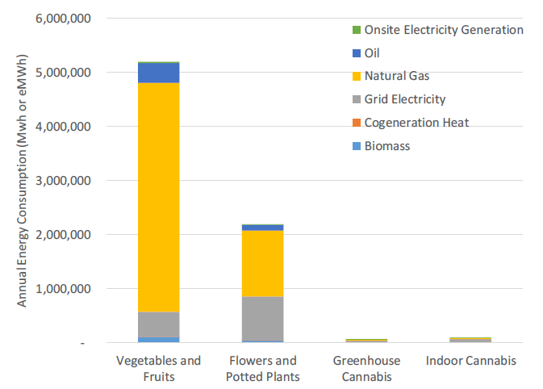
• A lit vegetable greenhouse consumes 10 times as much electricity as an unlit vegetable greenhouse, with essentially all the additional electricity used for lighting.
• A lit flowers greenhouse consumes 4 times as much electricity as an unlit vegetable greenhouse.
• Indoor cannabis facilities use almost 3.5 times more electricity per square foot than lit vegetable greenhouses.
• Indoor cannabis facilities use 1.4 times more electricity than cannabis produced in greenhouses.
Forecasted Energy Consumption has been constantly growing: 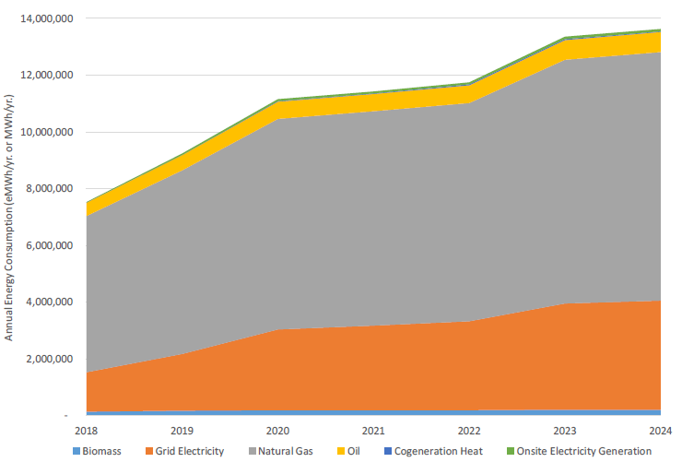
Maintaining the ideal temperature within the greenhouse is the most important aspect of the thermal management systems of a greenhouse operation. Max and minimum temperatures must be maintained to avoid plant stress or loss.
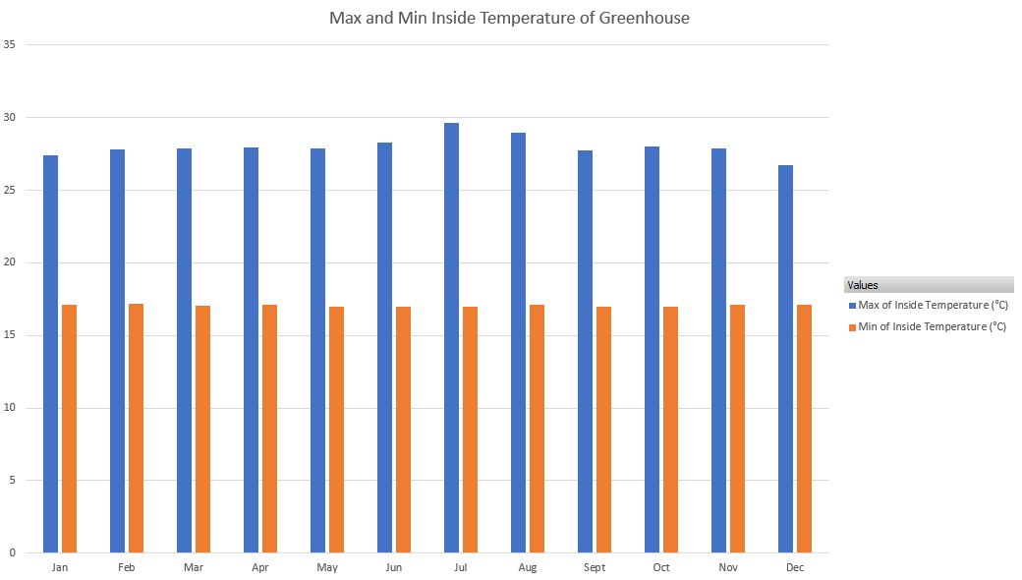
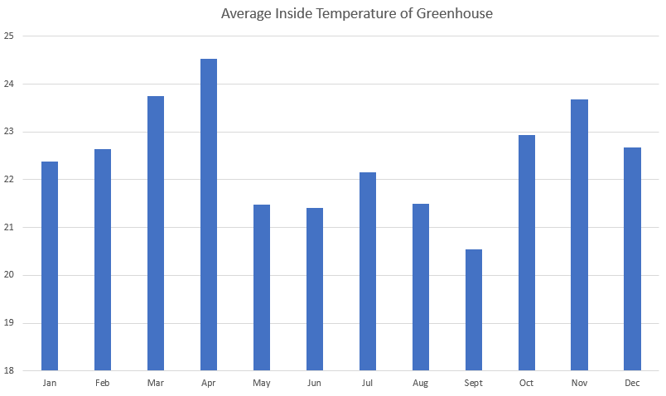
Our analysis is based on the following major assumptions:
- Steady-State Conditions: The system is assumed to operate at a constant, unchanging state over time.
- Adiabatic System: We assume no heat is lost to the surroundings (i.e., the system is perfectly insulated).
- Ideal Heat Transfer: The heat exchanger is modeled as ideal, implying maximum possible heat transfer efficiency.
- Incompressible Flow: Fluid properties (such as density and specific heat) are treated as constant.
The size of the data centre is 100 MW which satisfies 45 MW heating demand of the greenhouse if no other heating source is utilized. In general, at lower latitudes (40 to 50 degrees the heating requirements range from 250 to 430 kWh/m2/y, whereas, in higher latitudes (50 to 60 degrees) the heating needs range from 430 to 650 kWh/m2/y (Source). In terms of size of greenhouse, basically high tech greenhouses produce 250 to 600 tonnes of tomatoes per hectare (Source).

Ambitious Scenario: Direct Thermal Integration
This scenario represents the maximum potential for synergistic integration, aiming for the highest possible waste heat utilization rate.
Principle: Direct utilization of low-grade datacenter waste heat to supply the majority, if not all, of the thermal energy required for greenhouse vegetable cultivation.
The hot air or fluid (e.g., water or a specific coolant) exiting the datacentre's cooling system is immediately routed to the greenhouse's heating infrastructure. This involves an air-to-air heat exchanger system or, more efficiently, a liquid-to-air heat pump/exchanger system that directly supplies the greenhouse's heating pipes (e.g., bench heating, under-bench pipes, or finned-tube radiators).
Example: Data Center-Greenhouse architect (100%, 24 hrs heat from Datacenter)
The foundational assumption for the technical analysis is a hyperscale datacenter with a total electrical capacity of 100 MW. Based on a conservative thermal load factor of 45%, the waste heat generation potential is calculated to be a consistent 45 MWh. The technical and economic analysis assumes a 100 MW hyperscale datacenter. Based on a conservative 45% thermal load factor, it has a consistent waste heat generation potential of 45 MWh. This heat, typically vented via cooling towers, will be recovered and supplied to a co-located controlled-environment greenhouse via a custom, high-efficiency plate heat exchanger.
Thermal modeling is based on specific ΔT assumptions for optimal operation:
- Supply Differential: The hot fluid supplied to the greenhouse will be 1°C lower than the fluid returning from the datacenter.
- Return Differential: The fluid returning from the greenhouse will be 1°C lower than the fluid returning to the datacenter's cooling plant.
Water is the primary heat transfer fluid for both loops due to its properties and cost-effectiveness. Pump selection and sizing, along with their energy consumption modeling, are governed by the Affinity Laws and typical efficiencies. The direct CO2 emission is calculated as per energy saved which is basically saving natural gas for greenhouse heating which has 53.06 kg CO2 per mmBtu (181.07 kg CO2 per MWh) (Source).
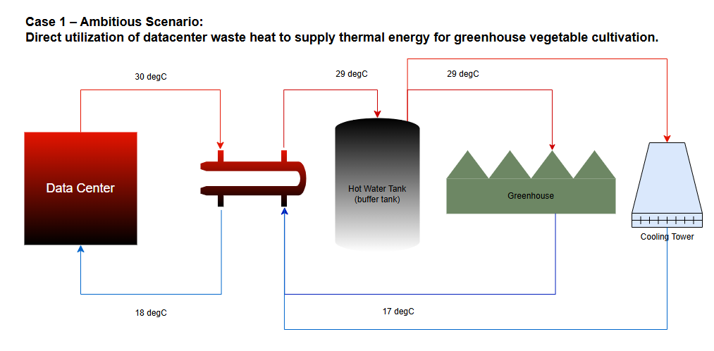
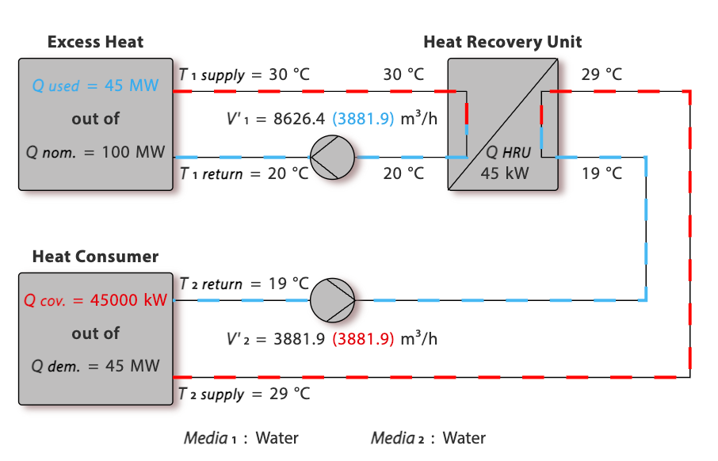
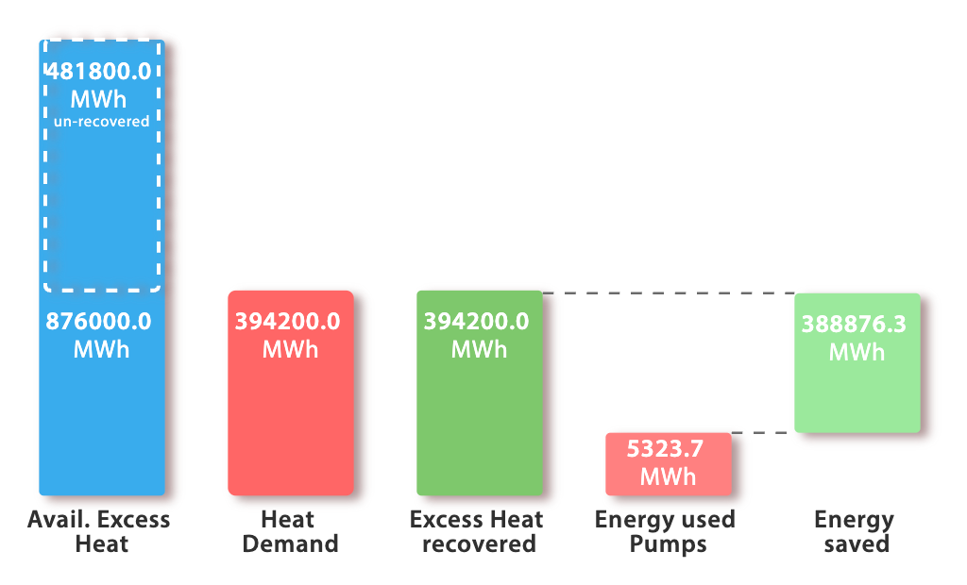
The annual direct CO2 reduction resulting from this integration, based solely on the net energy savings, is calculated to be 70,402.45 tons.
In summary, 100 MW datacentre supplied heat to a 45 MW thermal demand greenhouse of ~91 hectare land size with annual tomato production of ~27,000 tons where this integration shows direct CO2 reduction of ~70,500 tons annually from greenhouse industries.
Technical Challenge: Requires tight control over the datacentre's operating temperature and the greenhouse's heating demand, as fluctuations in one can directly impact the other. The datacentre's waste heat temperature often needs to be slightly boosted via a heat pump to meet optimal greenhouse growing temperatures.
Drawbacks: Less flexibility for either facility to operate independently; system failure in one could critically affect the other.

Theoretical Scenario: Baseline Heating Satisfaction and Integrated Energy Loop
This scenario focuses on reliable, continuous heat supply to cover the greenhouse's constant, predictable heating load, while formally embedding the datacentre heat source within the existing greenhouse energy infrastructure.
Principle: The datacenter serves as the primary, non-interruptible heat source, specifically targeting the greenhouse's hourly baseline heating demand. This baseline demand typically covers structural heat loss and minimal environmental maintenance during periods of moderate weather.
Baseline Supply: The datacenter's recovered heat is consistently supplied to satisfy the minimum hourly thermal energy requirement of the greenhouse, specifically 10% to 20%. The remaining heating requirement is supplied by the greenhouse's current energy sources.
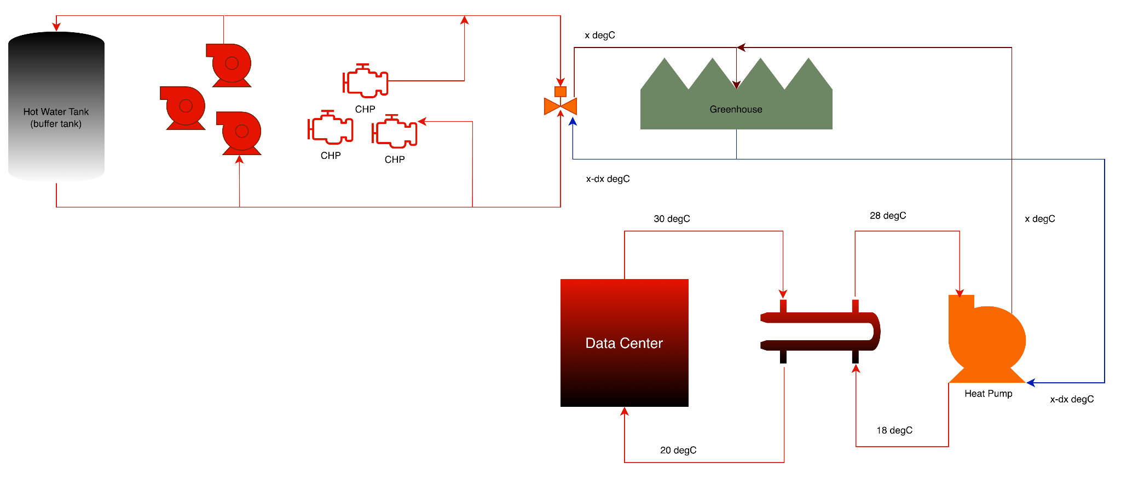

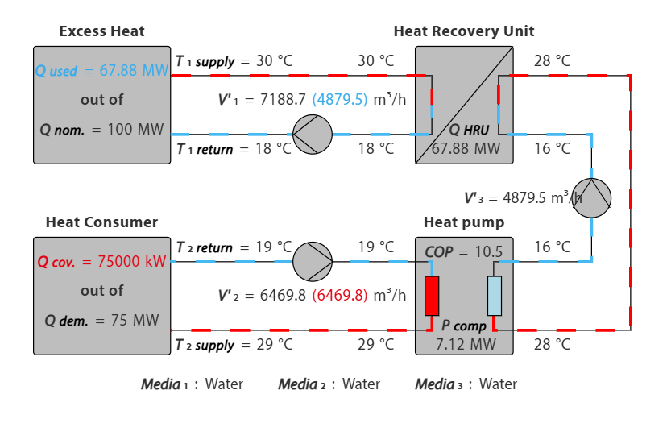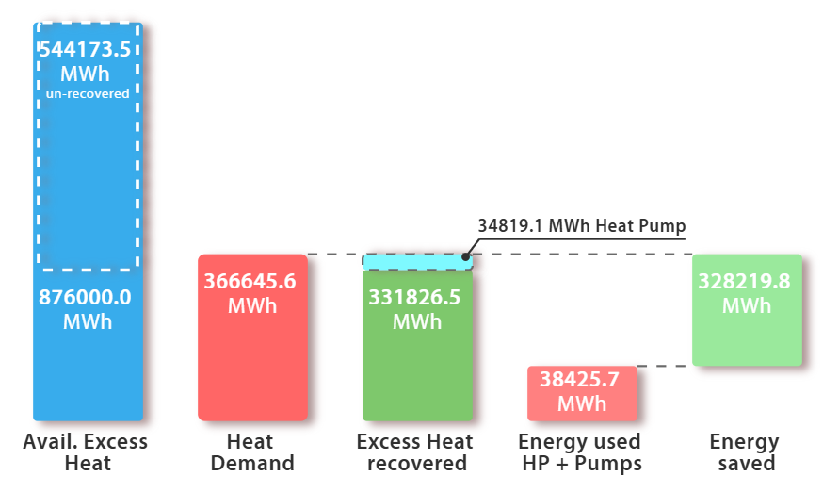

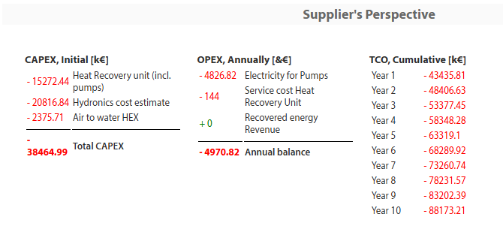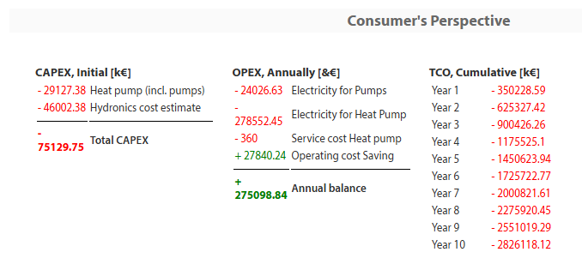

Practical Scenario A: Thermal Storage-Centric Approach
This is a highly practical and common approach, utilizing thermal energy storage as a buffer between the two facilities.
Principle: Decoupling the real-time heat production (datacenter) from the real-time heat consumption (greenhouse) using a large-capacity hot water storage tank.
All recovered heat from the datacentre is delivered to a dedicated hot water storage tank (often referred to as a thermal storage or tank). The greenhouse then draws heat from this storage tank as needed. This approach is highly effective because:
Load Shifting: The datacenter can operate consistently, while the greenhouse needs heat intermittently (e.g., high demand at night, low demand during the day). The storage tank manages this temporal mismatch.
Temperature Buffering: The tank allows for temperature homogenization, reducing thermal shocks to the greenhouse system.
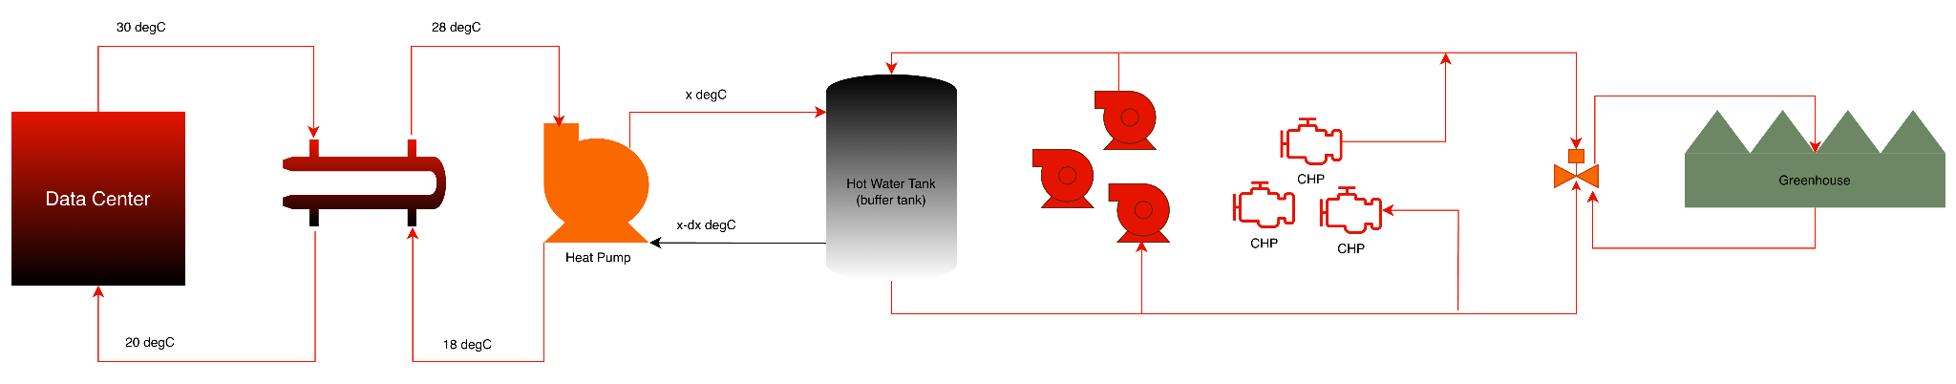
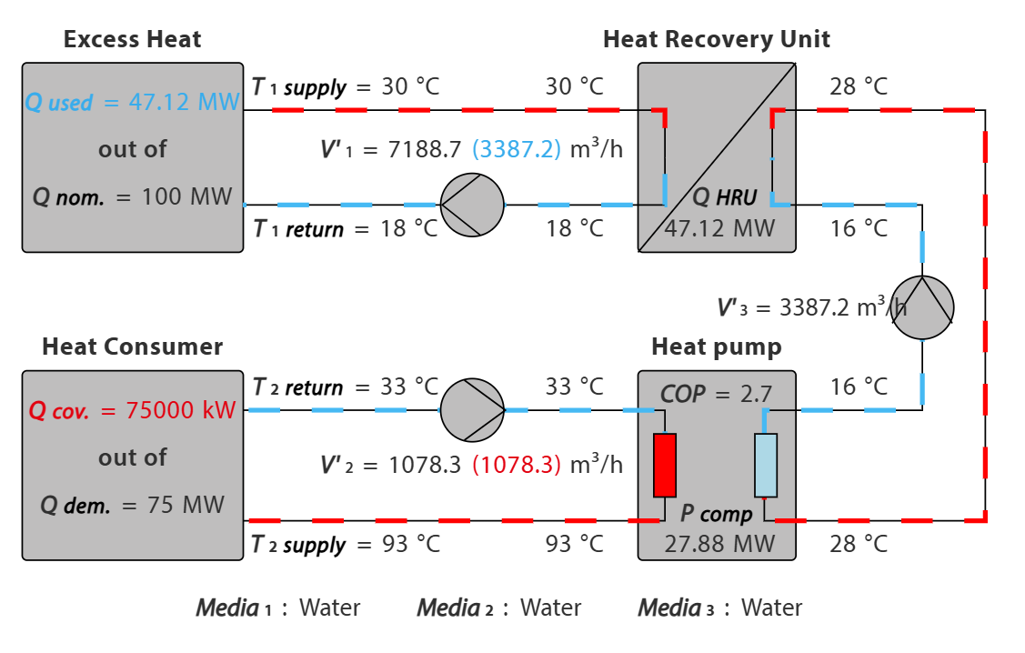
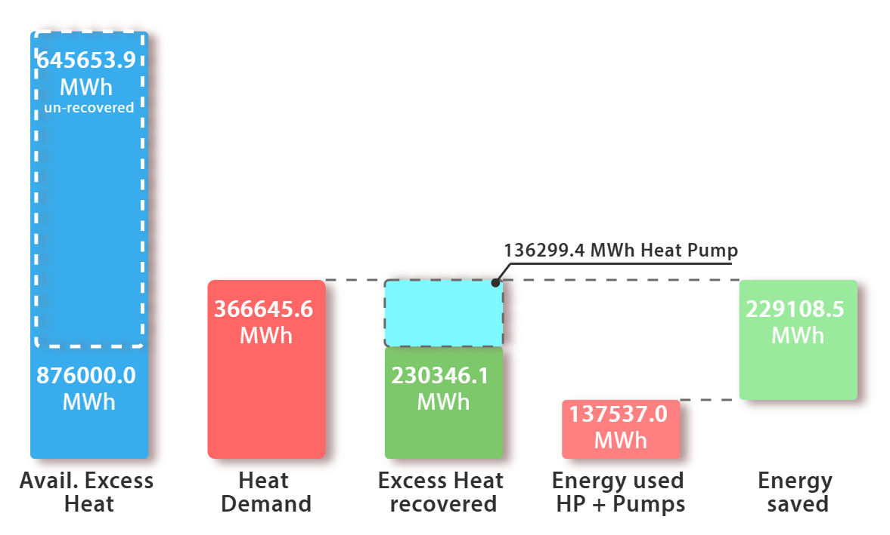
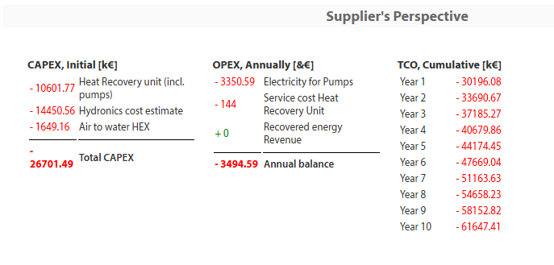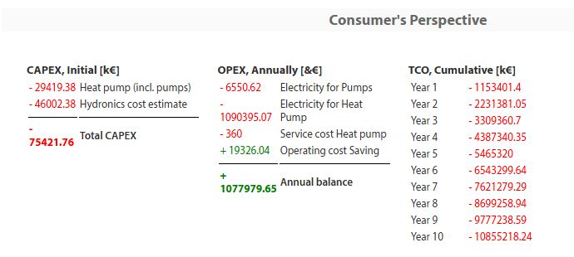

Practical Scenario B: Adding heat at point of use
This scenario is focused on using the datacentre heat to pre-condition the primary water inputs to the greenhouse.
Principle: Utilizing recovered heat to raise the temperature of the cold water feed before it enters the final heating components.
The datacenter heat is supplied directly to the greenhouse's feed water mixing valve or a pre-heating stage for the water loop. The main application here is pre-heating the water used for:
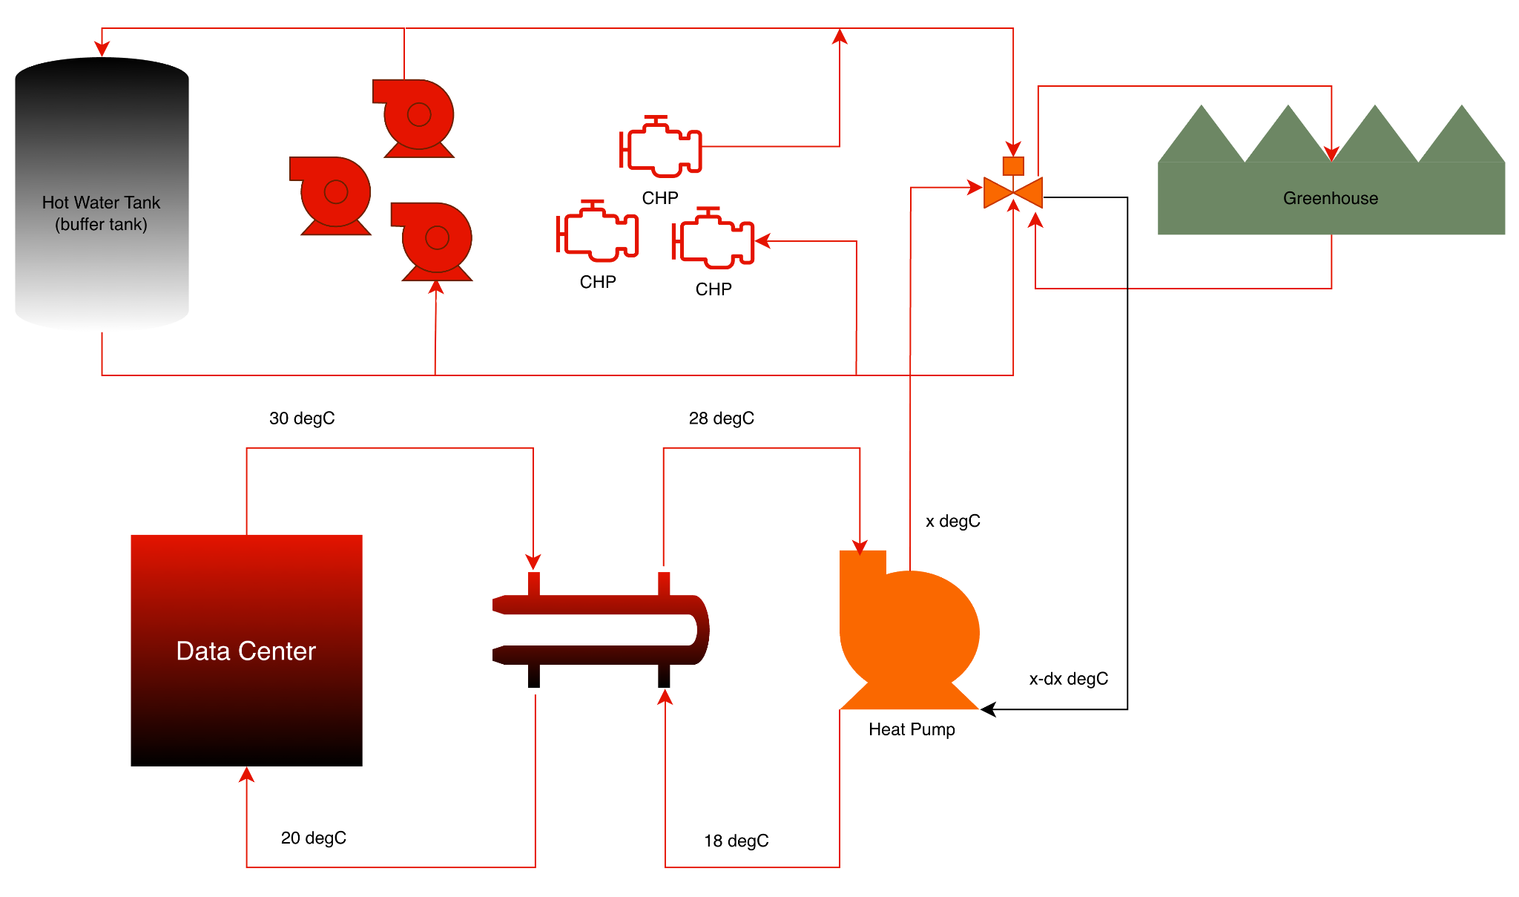

Modeling:
Technical Input
User of excess heat is: External use
Type of heat recovery: HEX (separation) and HP (boost)
Heat source: Data center cooling (fluid)
Excess heat available capacity: 100 MW
Excess temp. supply side: 30 ˚C
Excess temp. return side: 18 ˚C
Heat demanded by user: 75 MW
Supply temp. from HP: 93 ˚C
Return temp. from consumer: 33 ˚C
Availability and demand match: See diagram Energy & Emission
Current type of heating: Gas Boiler
Cost of current type of heating: 0.0839 €/kWh
Cost of electricity: 8 €/kWh
Agreed heat sales price: 0 €/kWh

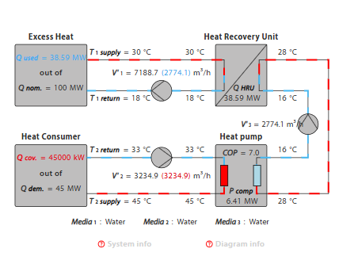
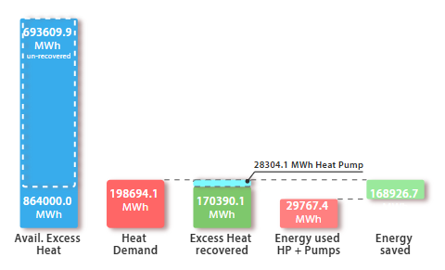

Assumptions:

Datacenter Heat:
-12°C ΔT from input to Output
3 scenarios: 30°C, 45°C, and 60°C
Datacenter delivering 30°C returning 18°C to the datacenter

Electricity:
$80/MWh

In March 2025, the average electricity price for businesses in the Netherlands was approximately €0.208 per kWh, including all taxes and fees. However, prices for very large industrial consumers, such as a large greenhouse in Middenmeer, can be lower due to potential tax exemptions and direct purchasing agreements.
Specific rates published for energy customers at Dutch horticultural hubs in 2025 were around €0.16 to €0.162 per kWh. This specific figure is likely more representative of the costs for a large greenhouse operation.
Factors influencing the final cost per kWh for a large greenhouse include:
- Consumption volume: Large consumers often pay less per kWh than medium or small businesses.
- Taxes and levies: The effective cost is significantly impacted by non-recoverable taxes and levies, which can vary depending on specific industrial exemptions.
- Wholesale market fluctuations: Prices in the wholesale market have fluctuated, with average prices around USD 90/MWh (€80-85/MWh) in H1 2025, suggesting that very large users with direct access to wholesale markets or Power Purchase Agreements (PPAs) might achieve lower effective costs, excluding distribution fees and taxes.
- Energy source: Greenhouses increasingly use combined heat and power (CHP) units or renewable energy sources, which can alter their overall energy cost balance.
Ultimately, a large greenhouse operation in Middenmeer would likely be paying an effective rate per kWh closer to the industrial consumer price, possibly in the range of €0.15 to €0.21 per kWh depending on their specific contract terms and energy management strategies.

Natural Gas:
€0.0839 per kWh

As of November 2025, the cost of natural gas for a large greenhouse in Middenmeer, Netherlands, is primarily based on commercial tariffs and specific tax structures for the horticulture sector.
While precise, real-time contract prices vary, general price data for large business consumers in the Netherlands during the first half of 2025 indicated a price of approximately €0.0839 per kWh (including all non-recoverable taxes and levies).
Key factors and current market context:
- Business Tariffs: Commercial rates are typically lower than household rates, but the final price depends heavily on the specific contract type (e.g., spot market prices, which many growers use, or fixed contracts).
- Taxation: The horticulture sector has historically benefited from a reduced energy tax rate. However, the government is increasing this tax gradually. In 2025, the tax on natural gas for a large user (consuming 170,000 to 1 million cubic meters annually) is projected to be around €0.159 per cubic meter (equivalent to approximately €0.017 per kWh, assuming 1 m³ ≈ 9.5 kWh).
- Market Benchmarks: The benchmark Dutch natural gas futures (TTF Gas) price as of November 3, 2025, was around €31.83 per MWh, which translates to approximately €0.03183 per kWh on the wholesale market, before distribution costs, taxes, and supplier margins are added.
- Future Costs: The Dutch government is introducing a mandatory green gas blending requirement and including the sector in the new EU Emissions Trading System (ETS-2), which is expected to lead to increased costs in the coming years.
The final cost will be a combination of the wholesale market price, distribution network costs, taxes, and supplier margins, likely resulting in a final price to the large greenhouse operator in the range of €0.05 to €0.10 per kWh (this range is an estimate based on available data and market components).
https://www.hortidaily.com/article/9727150/dutch-government-decision-angers-growers/#:~:text=Last%20week's%20leaked%20information%20has,national%20Recovery%20and%20Resilience%20Plan.
https://www.bloomberg.com/news/articles/2021-09-30/your-tomatoes-may-cost-more-as-gas-prices-hit-dutch-greenhouses#:~:text=Farm%20Trade%20Titans,the%20year%2C%20toppling%20prior%20records.
https://cedelft.eu/publications/evaluation-of-an-energy-charge-tariff-for-greenhouse-horticulture/#:~:text=Greenhouse%20horticulture%20currently%20enjoys%20a,incentive%20fund%20for%20greener%20energy.
https://www.hortidaily.com/article/9561287/prinsjesdag-budget-cabinet-comes-to-take-money-from-horticulture/#:~:text=or%20%E2%82%AC243).-,Boiler%20gas,here%20to%20enlarge%20the%20table.
https://ec.europa.eu/eurostat/statistics-explained/index.php/Natural_gas_price_statistics#:~:text=Then%2C%20it%20decreased%20every%20semester,(%E2%82%AC0.0531%20per%20kWh).
https://tradingeconomics.com/commodity/eu-natural-gas#:~:text=TTF%20Gas%20Hits%204%2Dweek,the%20US%20and%20Middle%20East.

